CS 255 System Design Document Template

This template lays out all the different sections that you need to complete for Project Two. Each section has guidance to prompt your thinking. You will need to continually reference the interview transcript as you work to make sure that you are addressing your client’s needs. There is no required length for the final document. Instead the goal is to complete each section based on what your client’s needs are. Remove this note when you are finished, and replace all bracketed text with the relevant information.

UML Diagrams

UML Use Case Diagram
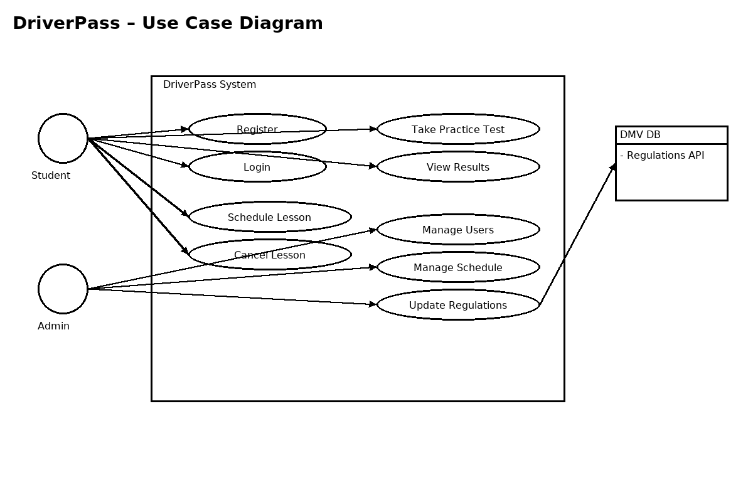

UML Activity Diagrams
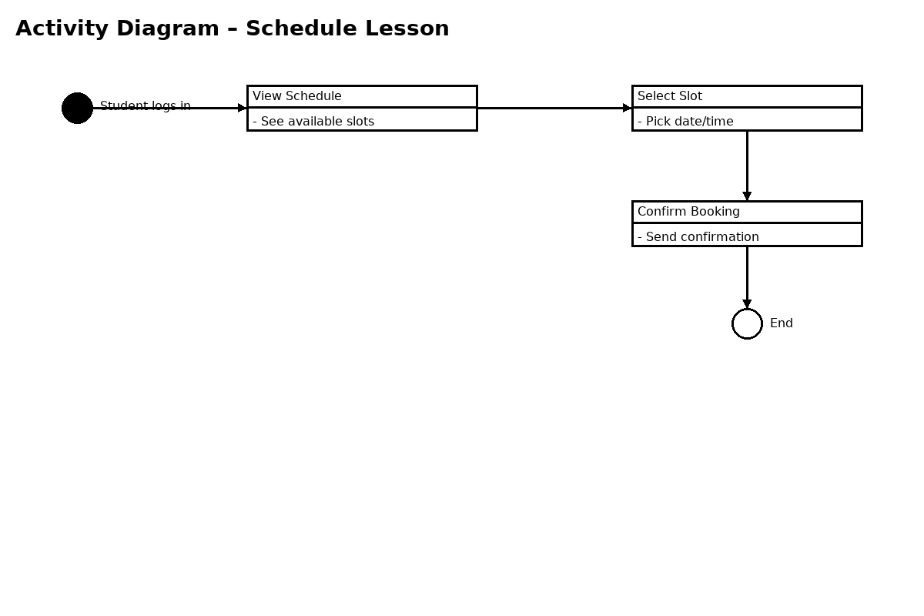

UML Sequence Diagram
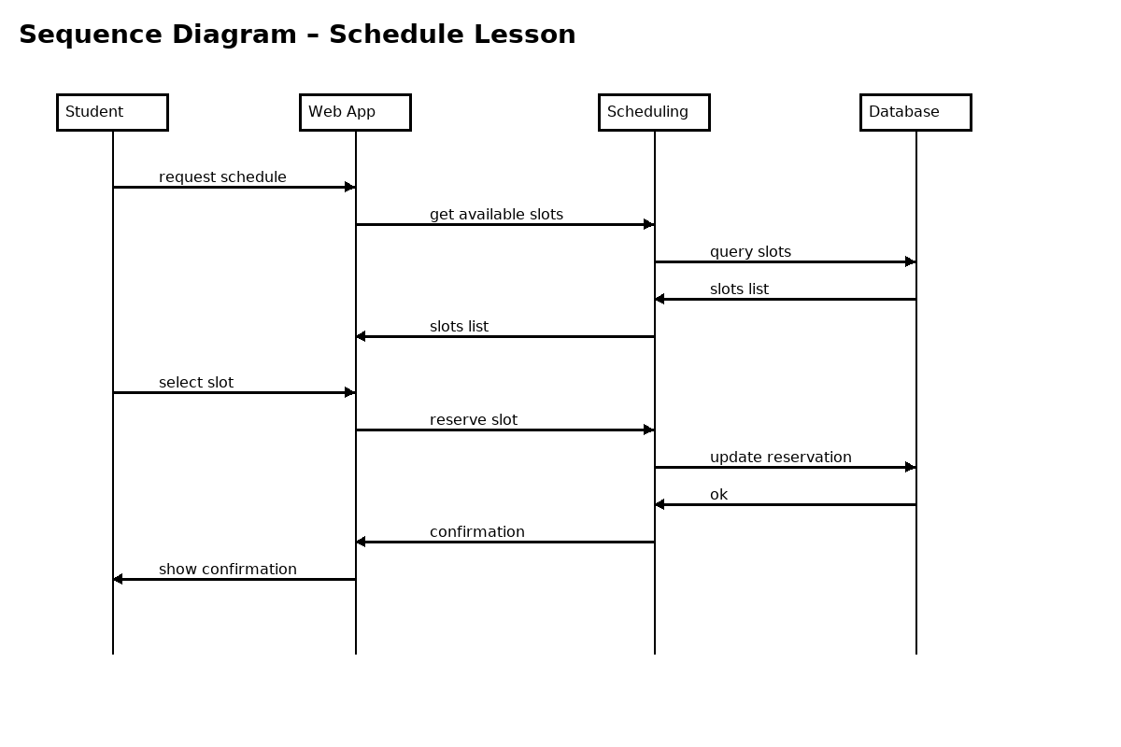

UML Class Diagram
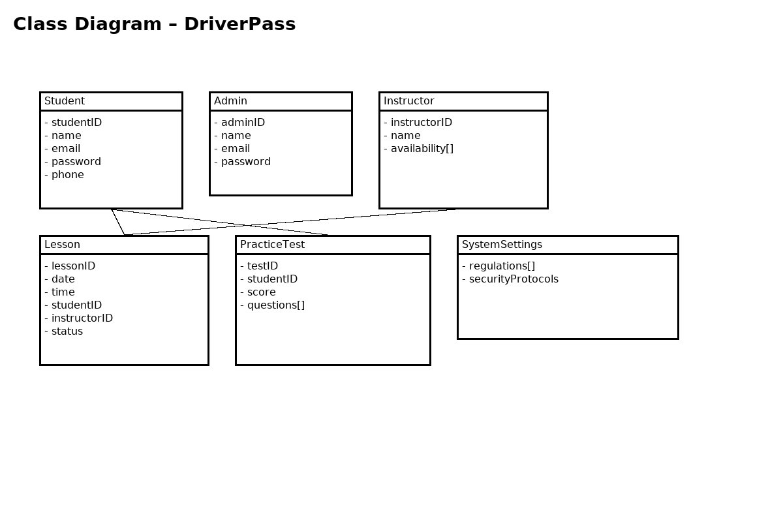

Technical Requirements
Hardware:
- Cloud-hosted web server (8 vCPU, 16 GB RAM, 200 GB SSD) for the application layer
- Managed PostgreSQL database (with encryption at rest and automated backups)
- Load balancer with TLS termination; Web Application Firewall (WAF)
- Nightly backup storage and offsite retention
Software:
- Backend: Java 17 with Spring Boot; RESTful APIs
- Frontend: Responsive web app (React) compatible with mobile devices
- Database: PostgreSQL 15 with connection pooling
- Security: TLS 1.2+ with HSTS; OAuth 2.0 / OIDC for authentication; RBAC for authorization
- CI/CD: Git, GitHub Actions, JUnit 5, JaCoCo, SonarQube
Tools & Integrations:
- Lucidchart for UML diagrams
- DMV Regulations API integration with retry/circuit breaker patterns
- Centralized logging (ELK/OpenSearch) and monitoring (Prometheus/Grafana)
Infrastructure:
- Multi-AZ deployment targeting 99.9% availability; autoscaling for traffic spikes
- Network segmentation with public/private subnets; least-privilege IAM policies
- Automated backups and point-in-time recovery; DR targets: RPO ≤ 24h, RTO ≤ 4h
- Privacy by design: data minimization, PII encryption, audit trails (90-day retention)
